A000-US-Sioux-Ledger Drawings

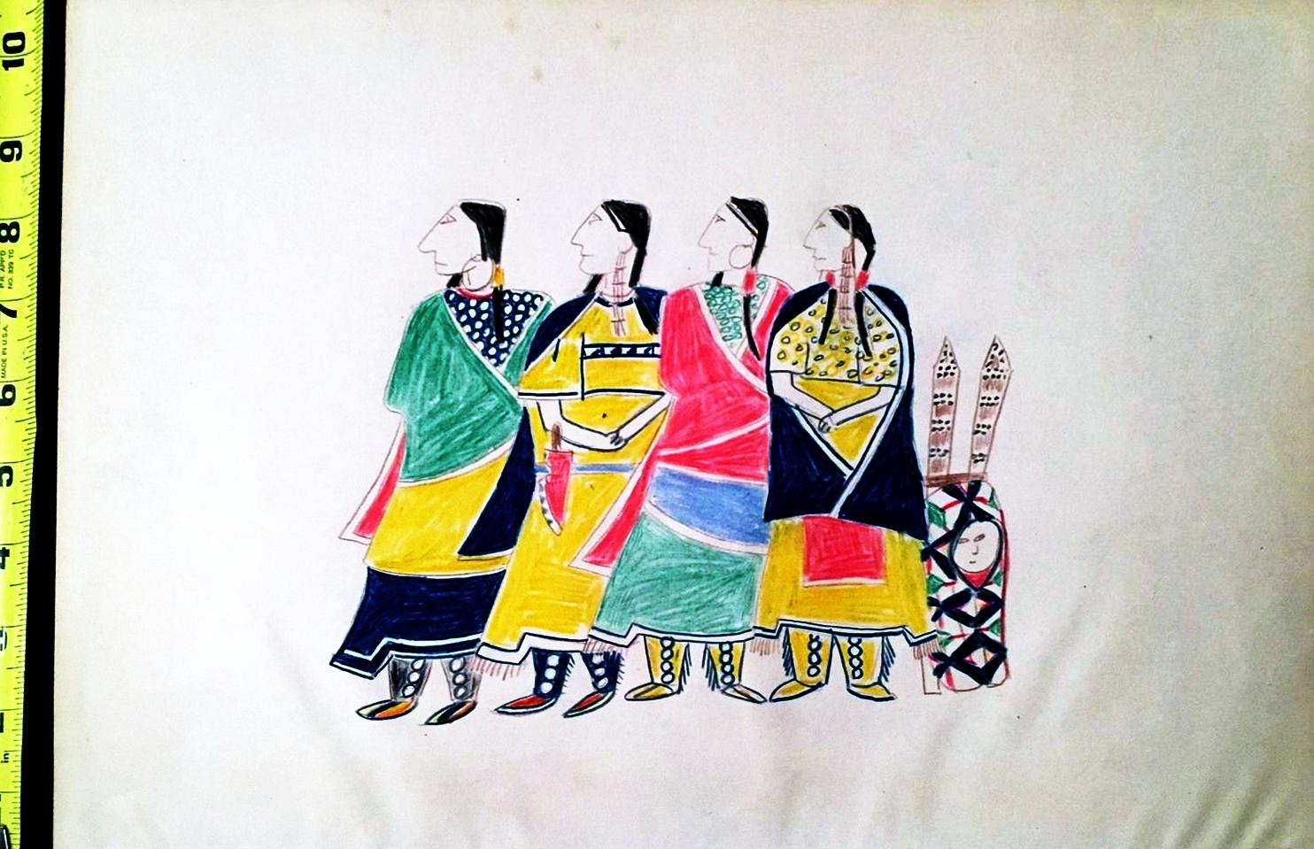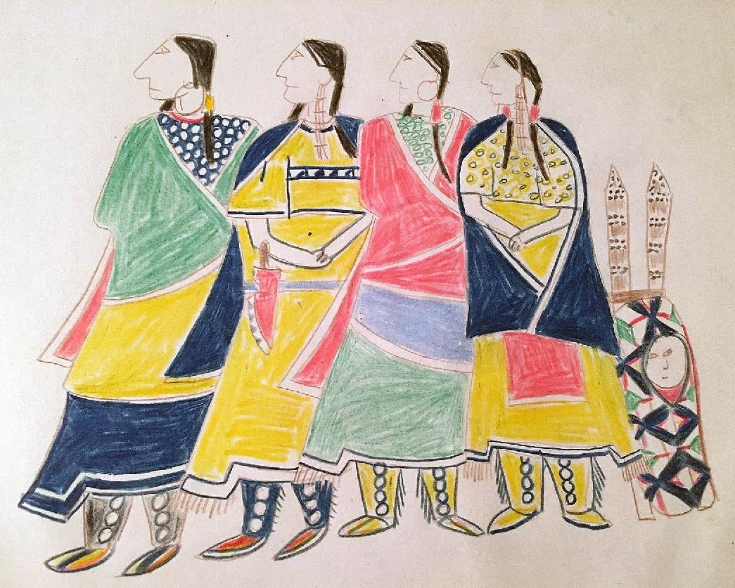

10 1/2" x 14 1/2"

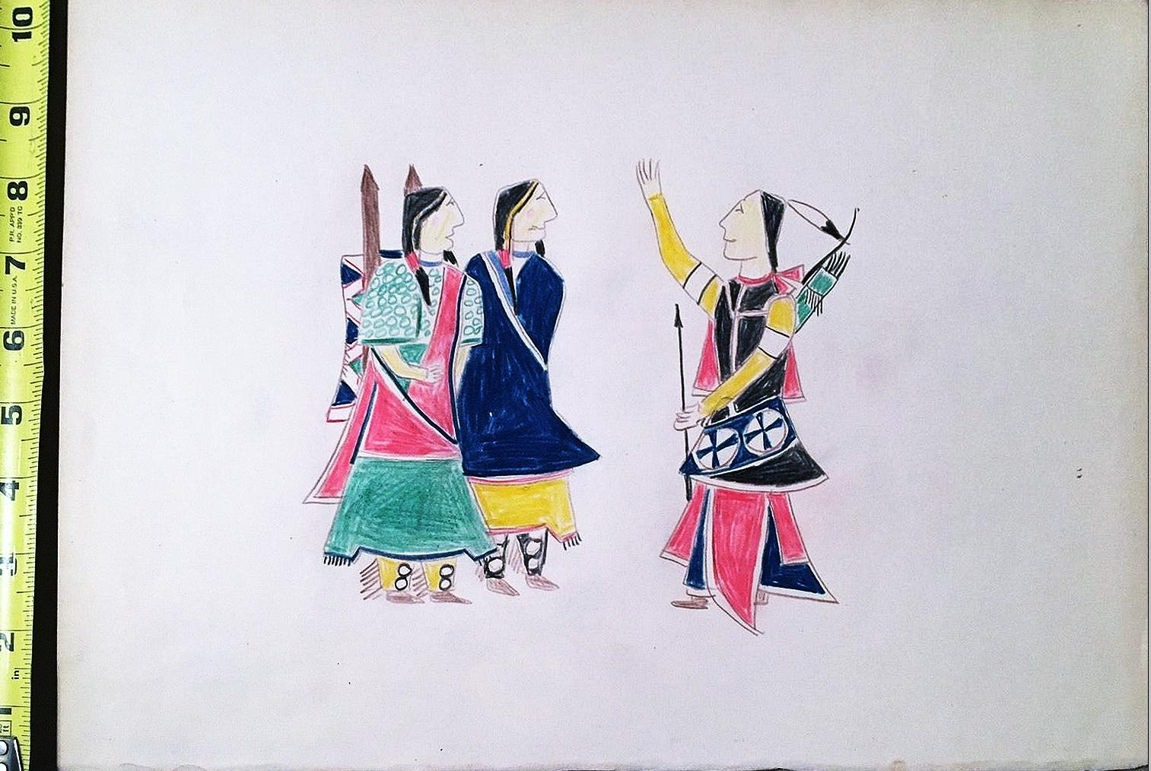

10 1/2" x 14 1/2"

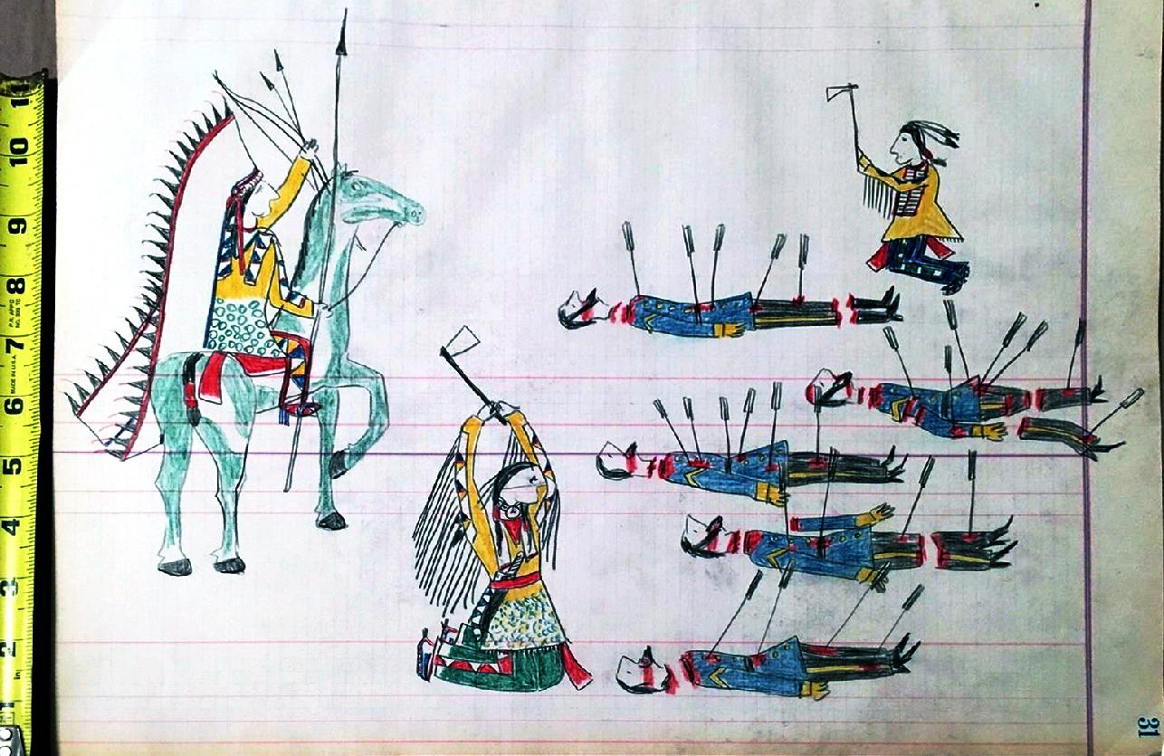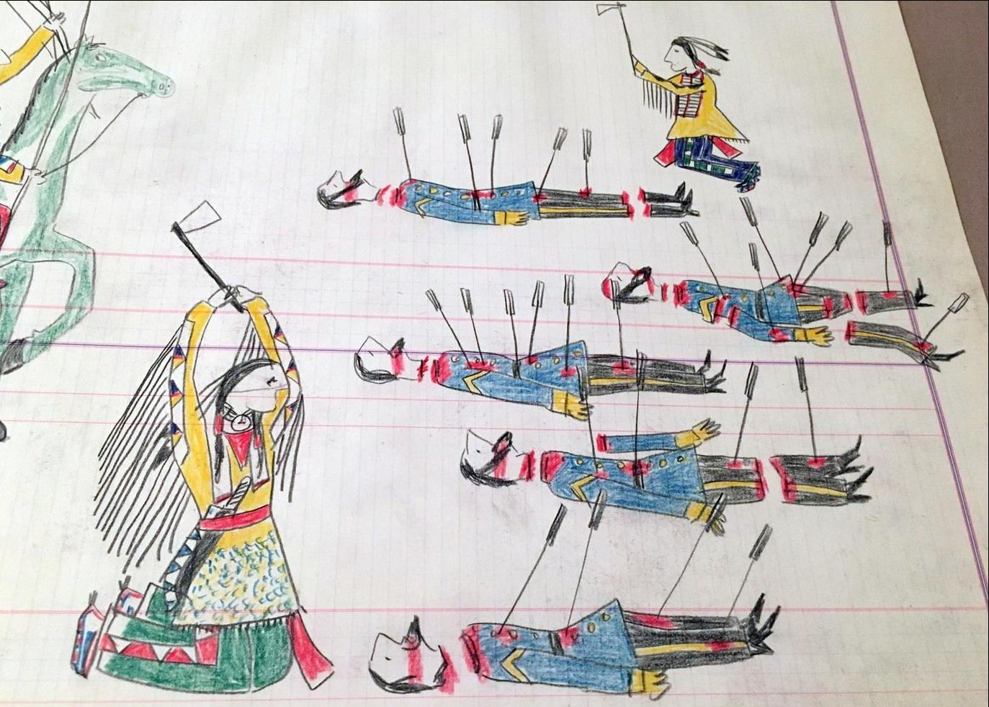

13" x 16 1/2"

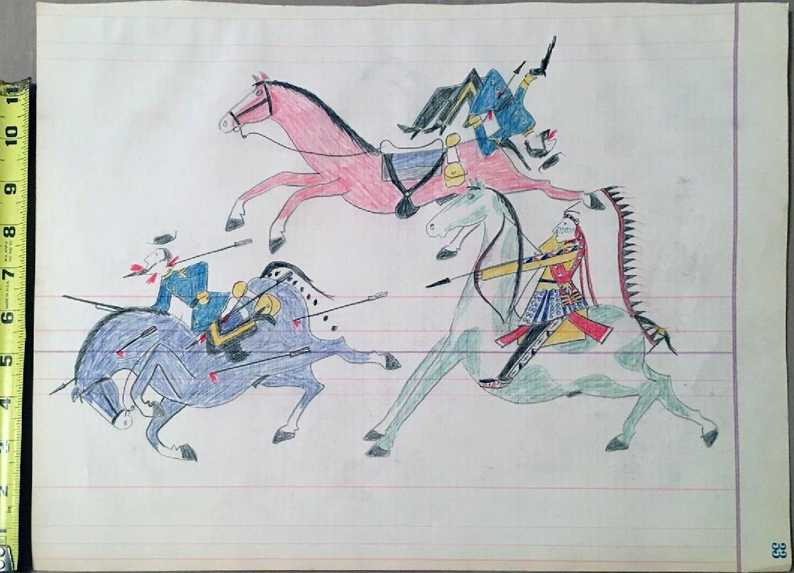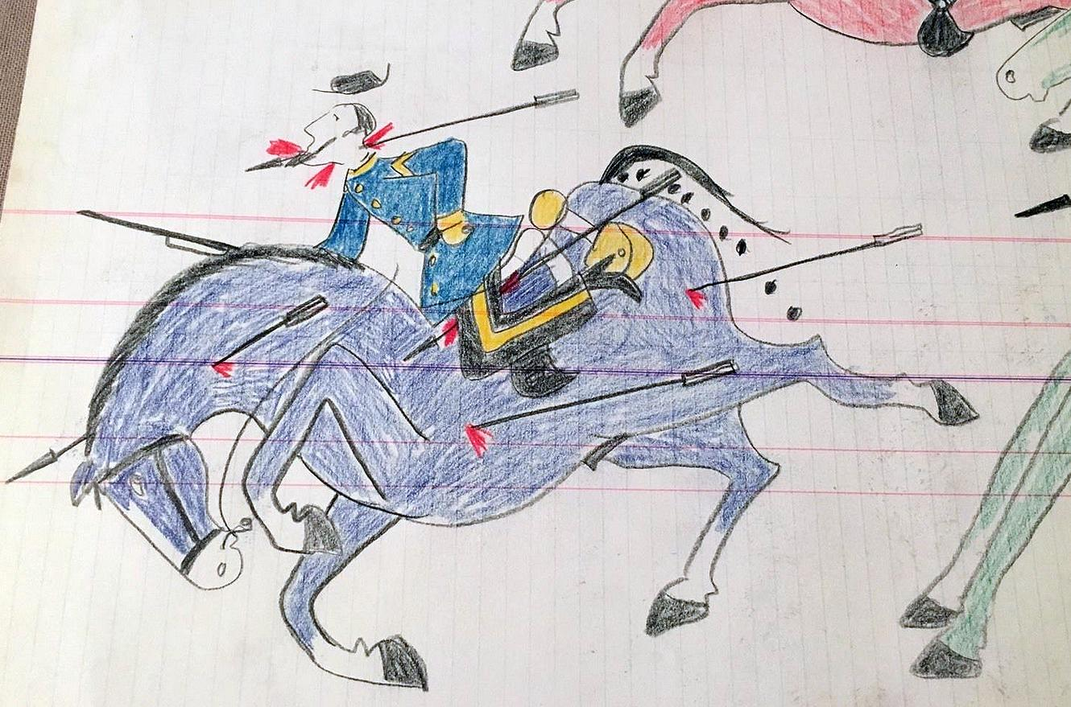

13" x 16 1/2".

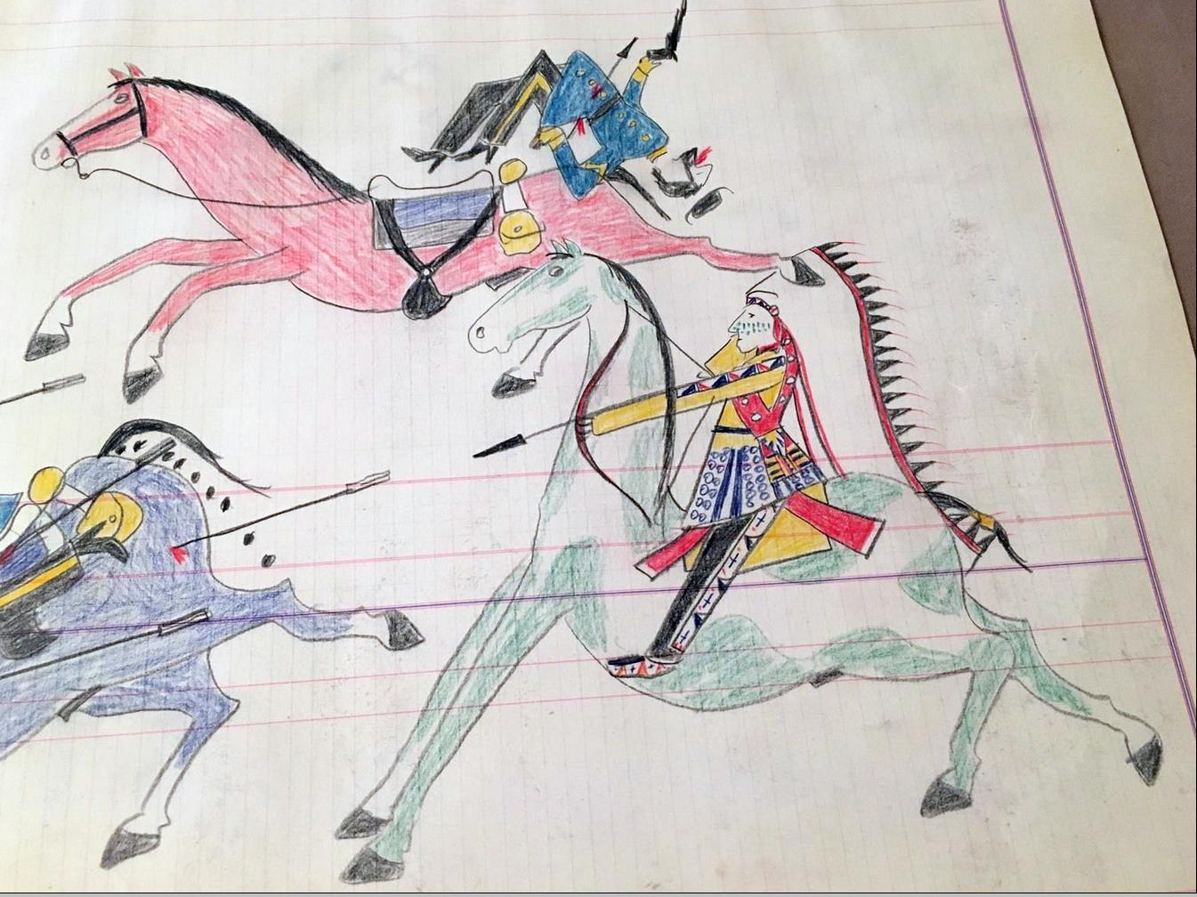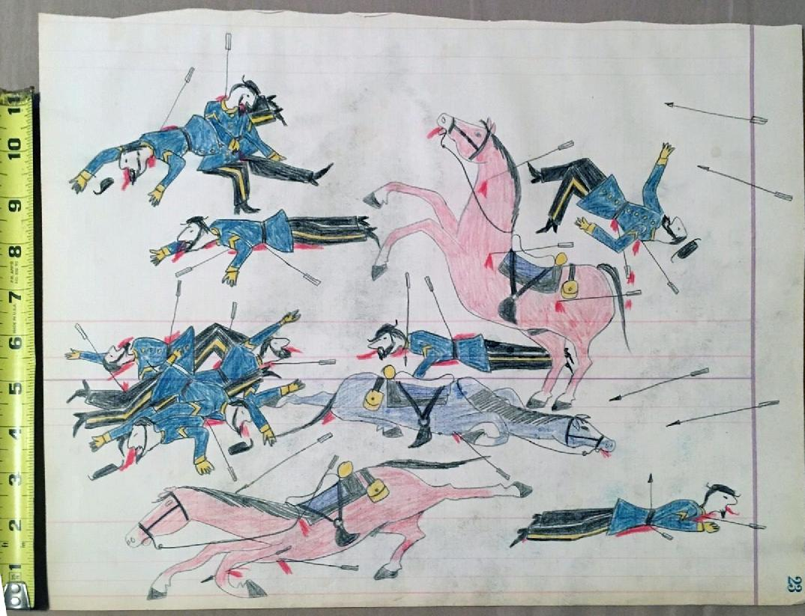

13" x 16 1/2"

|  |  |
| --- | --- |
| 13" x 16 1/2" | ORDER TOTAL  US $1,550.00  + US $35.00  shipping  **Order Ledger Drawing Native American Indian Very Nice,VINTAGE Ledger Drawing Native American Indian Estate Find,Ledger Drawing Native American Indian Killing Soldiers Estate Sale Find,Ledger Drawing Native American Indian Fighting Soldiers Estate Sale Find,Ledger Drawing Native American Indian Battling Soldiers Estate Sale Find** [View order details - ORDER DATE Apr 10, 2016](http://payments.ebay.com/ws/eBayISAPI.dll?ViewPaymentStatus&transId=1304370973013&itemid=231909000466&_trksid=p2057872.m2749.l2673)[Contact seller - ORDER DATE Apr 10, 2016](http://contact.ebay.com/ws/eBayISAPI.dll?ShowSellerFAQ&requested=onepeople43&iid=231909000466&redirect=0&_trksid=p2057872.m2749.l2652)  [More actions - ORDER DATE Apr 10, 2016](http://www.ebay.com/myb/PurchaseHistory) |